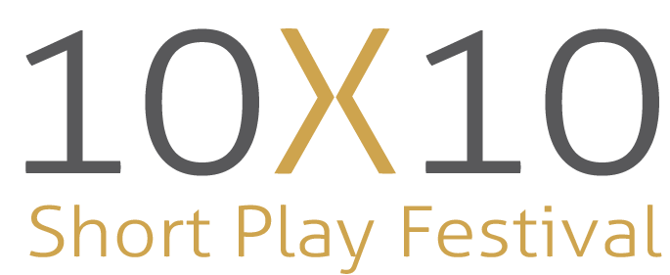
10x10 Director’s Questionnaire
About you:
Name: Click or tap here to enter text.
Address: Click or tap here to enter text.
Phone: Click or tap here to enter text.
Email: Click or tap here to enter text.
_____________________________________________________________________________________
By applying to direct, you are committing to be available for the following dates:
- Roundtable Readings: Saturday April 13th @ 10AM – 12PM
- Directing Workshop (Optional): Saturday, April 13 @ 12:30PM – 2:30 PM
- 10x10 Showcase Auditions: Saturday, April 20th & Sunday, April 21st @ 10AM – 2PM
- Casting Meeting: Sunday, April 21st @ 3PM
- Production Kick-Off: Monday, April 29th, 2024 @ 7:30PM
- Rehearsal Period: April 30th – June 2nd, 2024 (5 Weeks)
- Tech Rehearsals: Tuesday, June 4th & Wednesday June 5th, 2024 @ 6:45PM
- Dress Rehearsal: Thursday, June 6th, 2024 @ 6:30PM
- Festival Performances: Friday, June 7th, 2024 @ 6:30PM & Saturday, June 8th, 2024 @ 1PM & 6:30PM
- Potential Additional Festival Performance: June 9th @ 2PM
Directing for 10x10:
- Please outline any previous theatre experience that you may have. (Directing/Acting etc.)
Click or tap here to enter text.

- Why do you want to direct for the 10x10 Short Play Festival?
Click or tap here to enter text.

- What do you hope to gain from directing in this year’s showcase?
Click or tap here to enter text.

- What skills are you looking to develop?
Click or tap here to enter text.

- Is there any kind of subject material that you would prefer to avoid?
Click or tap here to enter text.

- Are you looking for opportunities to grow/challenge yourself? (i.e., step outside of your comfort zone, tackle more challenging material etc.)
Yes ☐ No ☐
If yes, please explain below:
Click or tap here to enter text.

- What qualities make a successful director?
Click or tap here to enter text.

- What do you expect to be the most challenging aspect of directing for 10x10?
Click or tap here to enter text.
- If selected as a director for 10x10, pictures or recordings may be made of rehearsals and performances for archival and promotional purposes. These may be used in local media (Thunder Bay Television, The Chronicle Journal, etc.) or Magnus Theatre publicity (including our website and print advertising). Every participant’s name will accompany their image whenever possible. There will be no monetary compensation for the use of any individual’s image. The created media are the property of Magnus Theatre, or the agent making the recording. As such, do you agree to your image being used for the purposes outlined above?
Yes ☐ No ☐
____________________________________________________________________________
Signature: Click or tap here to enter text. Date: Click or tap to enter a date.
Please note until sponsorships and additional funding are secured, honorariums for participation in the 2024 10x10 Short Play Festival are not guaranteed.

